How to Transfer a Person
Manual patient handling is broadly defined as the transporting or supporting of loads by hand or bodily force and includes lifting, lowering, pushing, pulling, moving or carrying. Patients may be heavy or hard to grip and must be treated with dignity, respect, and consideration for their capabilities.
The following are steps to properly move a person from one location to another. This is referred to as transferring a person or just a transfer. In this case, the person is being transferred from a bed to a wheelchair.
- Help him to roll towards the side of bed. Supporting his back and hips, help him to a sitting position with his feet flat on the floor.
- If you are using a transfer/gait belt stand in front of him and grasp the belt.
- If you are not using a transfer belt, stand in front of him and place your arms around his torso or hips.
- Brace his lower extremities with your knees to prevent slipping.
- Tell him you will begin the transfer on the count of 3.
- On 3, help him to stand.
- Tell him to pivot to the front of the wheelchair with the back of his legs against the wheelchair.
- Flex your knees and hips and lower him into the wheelchair.
- Have him hold the armrests for support.

Performing a two-person transfer
- Time the lift and communicate. If it is not synchronized, someone could get hurt.
- The caregiver in front of the patient shifts the patient forward from the chair to their feet.
- The caregiver in back of the patient is to guide the patient’s hips to perform a pivot to the surface you are going to.

Safety with transfer
- If the person cannot help with the transfer at all, you need to get assistance from another person.
- Don’t ever try to lift someone unless you’ve had proper training.
- The person should never put his arms around your neck during a transfer. It can pull you forward, make you lose your balance, or hurt your back.
- If you feel a strain in your lower back, stop the transfer and get help.

Proper Body Mechanics When Lifting
If you will be helping someone get up or into a chair, bed, or bath, be kind to your back!
Remember... it’s the only one you’ve got!
Any time you lift or move a person, use proper body mechanics to prevent stress or injury to
your back. Think of yourself as an athlete. If you’re on the injured list, you’re out of the game.
- Before lifting a person or moving anything, make sure you can lift or move it safely. Do not lift a person or a load alone if it seems too heavy.
- Spread your feet about shoulder width apart with one foot slightly in front of the other to provide a good base of support.
- Bend at the knees instead of the waist.
- Keep your back as straight as possible.
- Bring the person/load as close to your body as you can.
- Lift with your legs, using your stronger set of buttock and leg muscles.
- Keep your back, feet, and trunk together and do not twist at the waist. If it is necessary to change your direction when upright, shift your feet and take small steps. Keep your back and neck in a straight line.
- When possible, pull, push, or slide objects instead of lifting them.
- Before helping a patient stand, encourage her to:
- Lean forward.
- Use a rocking motion as momentum (if able).
- Move her legs off the bed or chair and put her feet firmly on the floor.
- Place your arms around her waist. Don’t allow her pull on your neck, but she may place her hands on your shoulders.
- Use her glasses and/or hearing aids. The more she can hear and see you, the better!

Material adapted from: Family Caregiver Handbook Washington State Department of Social and Health Services Aging and Disability Services Administration

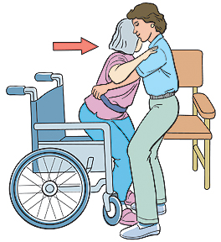
One person transfer using a transfer/gait belt

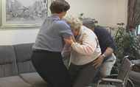
Two person transfer without transfer/gait belt

